**Total Marks: 30**

**Duration: 2hrs**

**CareerX Coding Assessment**

There are two sections in this Assessment and both are Coding based assessment sections.

**Each section is containing 15 marks**

**Section 1.** Help ABC Corporation to design Utility App for their employee. They can use this app to track their Official + Personal work and prioritize them.

Create a To-Do List page. where they can add their day-to-day routine work as list items and delete or modify them whenever required.

Refer to the layout as given below:

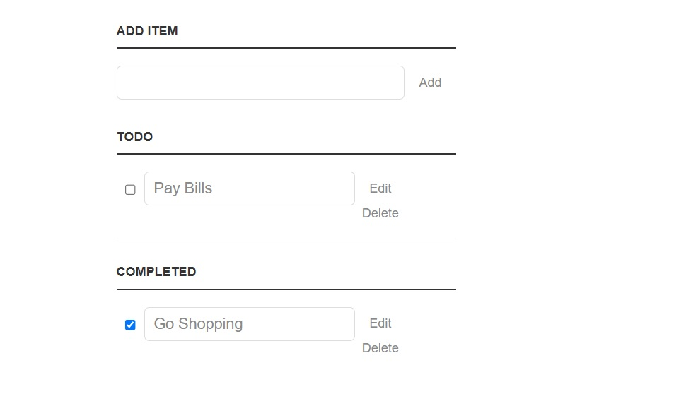

The app will have the following functionality:

1. User will add a task description in Text Field under Add ITEM section. while clicking on the add button it should be added to TODO list section as disabled Text Field.
2. When the user Clicks on the Edit Link under To-do Section then enable the text field to change the task description.
3. While clicking on Delete Link the task needs to be removed from To-do Item section.
4. While clicking on checkbox the task needs to be considered as Completed Task and need to get added to the Completed Task.

**Section 2. Create basic Login & Registration forms for User with all mentioned validation**

**Login Form**

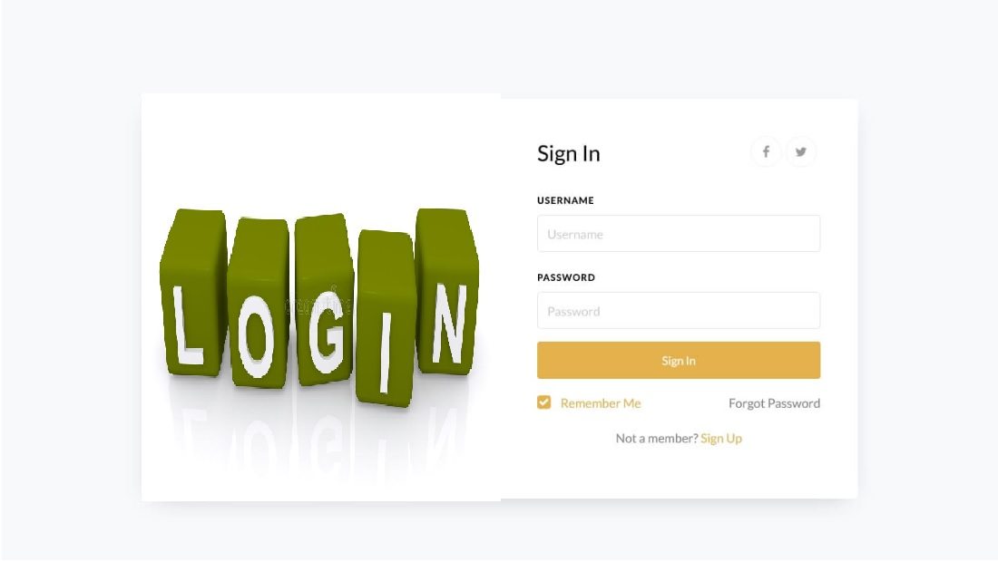

**Registration Form**

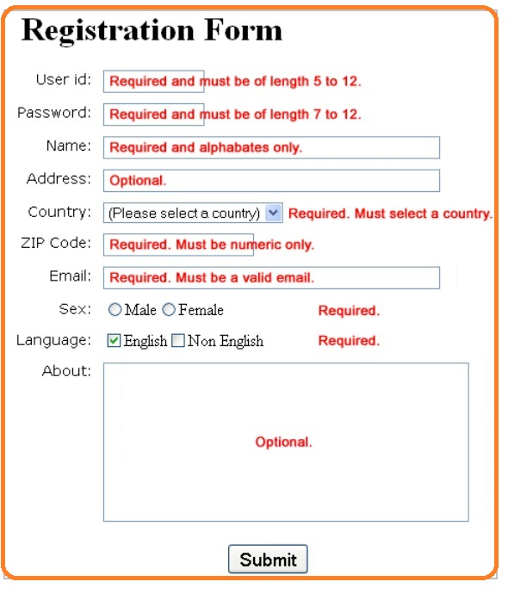

**Note :** add one more field called Phone No in Registration form which will accept on valid pattern of phone no as 0999-999999. Where first digit must be 0 [zero] and remaining three digits must be the area code for given phone no. Remaining number must contain 6 digits. Apply this validation using HTML5 pattern attribute.

**Important Note:** We are going to share a Repository link to which you suppose to commit your code. Put your code under a directory with the given name & structure.

YourName_Assessment main directory. It should contain two sub-directories as section1 & section2 respectively to put your assessment solution. Commit directory ‘yourName_Assessment’ to the repository

Repository Link :